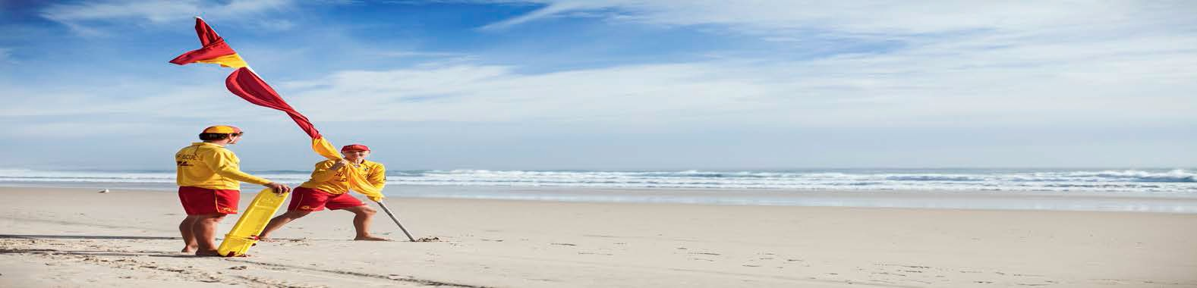
2017-18 UMINA
COURSE CALENDAR

Course | Date | Lead Trainer | Comments
IRB CREW/DRIVER | 07-08-2017 | Jim Irwin | Rolling courses all year, contact Jim (0456 186 564) for theory dates to commence tng.
Advanced Resuscitation Tech (ART) | In Sept holidays | Jarryd Edmonds | This course conducted primarily for Duke of Ed participants. Jarryd 0423 906 865.
Surf Rescue Certificate (SRC) | As required | Pam Edmonds | Contact Pam (4341 0347) or Age Manager for more details
SRC to Bronze (bridging tng) | As required | Pam Edmonds | Contact Pam or Age Manager for more details
Bronze Medallion/ Cert II | 15-10-2017 | Bob Powell | 9.00am, Sharpe room, Contact Bob for more details : 0427 143 050
First Aid (AID) | 04-11-2017 | SLSNSW | Start time TBA. Contact Jane (Umina office) 4342 0320 to enroll.
Advanced Resuscitation Techniques (ART) | 12-11-2017 | Bob Powell | Run in conjunction with Bronze course 15 10-17, contact Bob for specific dates.
Bronze Medallion/ Cert II | 04-02-2018 | Bob Powell | 9.00am, Sharpe room, Contact Bob for more details : 0427 143 050
Advanced Resuscitation Techniques (ART) Early Nov. Bob Powell Run in conjunction with above Bronze course, contact Bob for specific dates. | Early March | Bob Powell | Run in conjunction with Bronze course 4-2-18, contact Bob for specific dates.

Notes: All branch facilitated courses can be found on the SLSCC web site/education.
Please contact our club office (Mon, Fri, 4342 0320) to book into any branch courses.
SLSNSW First Aid courses: http://www.surflifesaving.com.au/first-aid-courses

