Coolangatta 16
We had two teams make the trip up to the Gold Coast this year. After another winter season of training we were all ready, or as ready as you can be. One of the big thinks about the Gold is your never %100 on the conditions until race day. This year the wind was coming from the south so that benefitted the ski paddlers and made it a bit harder for the board paddlers.
Divided we stand Team Stingray (left) Umina Breakers (right)
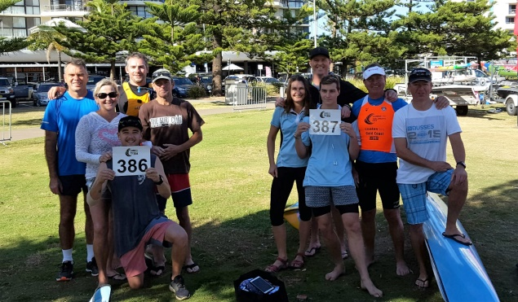
Team Stingray: Shane Lloyd (ski) Dean Tetley (run) Fiona Lloyd (swim) and Gary Wilson (board) Andy Boylan (water safety)
Umina Breaker: Dave Bishop (ski) Christine Bishop (run) Mick Magurren (swim) Rick Boylan (board) James Bishop (water safety)

We had 3 debutants this year Dean, Shane and Fiona and they loved the experience and that’s why we keep doing this year after year. Some have done the full and short course and teams before up to 4 times. I think that the thing that makes the Gold so special is that everyone is looking after each other to make this one of the best experiences in competing that I have been involved in over the years.
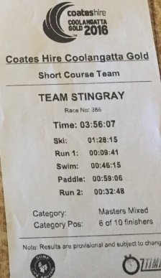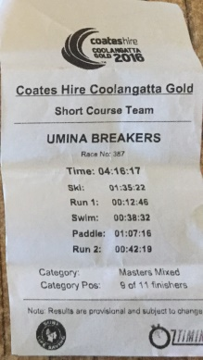
We finished up 6th and 9th overhaul and were only 7 minutes of a podium finish. Team Stingray had the fastest runner of both legs and the second fastest board paddler. Umina Breakers had the second fastest swimmer. So things are looking good for next year!!!
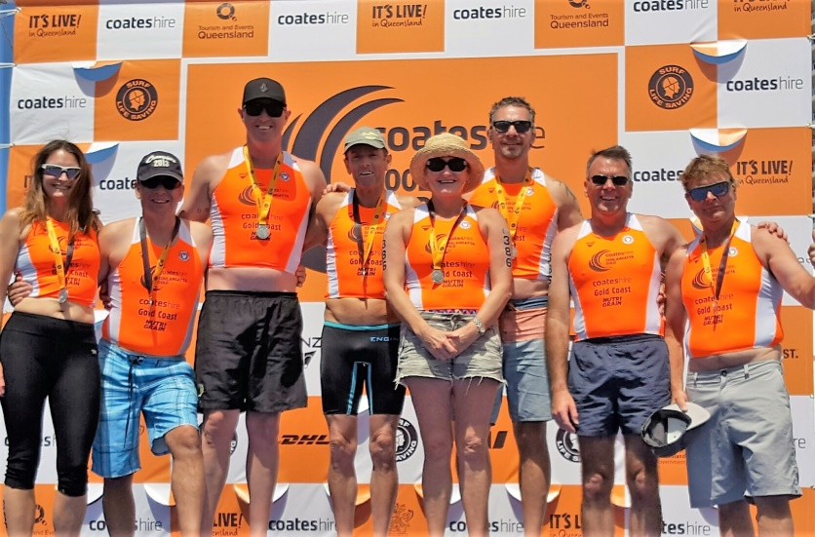
Big thank you to all the Handler’s
Lisa and Steve Funnell
Lorretta Wilson
Mandy Boylan
Last but not least Mick and Andrew for driving the gear up and Andrew and James for water safety

Rick Boylan, Master Coordinator 16-17

