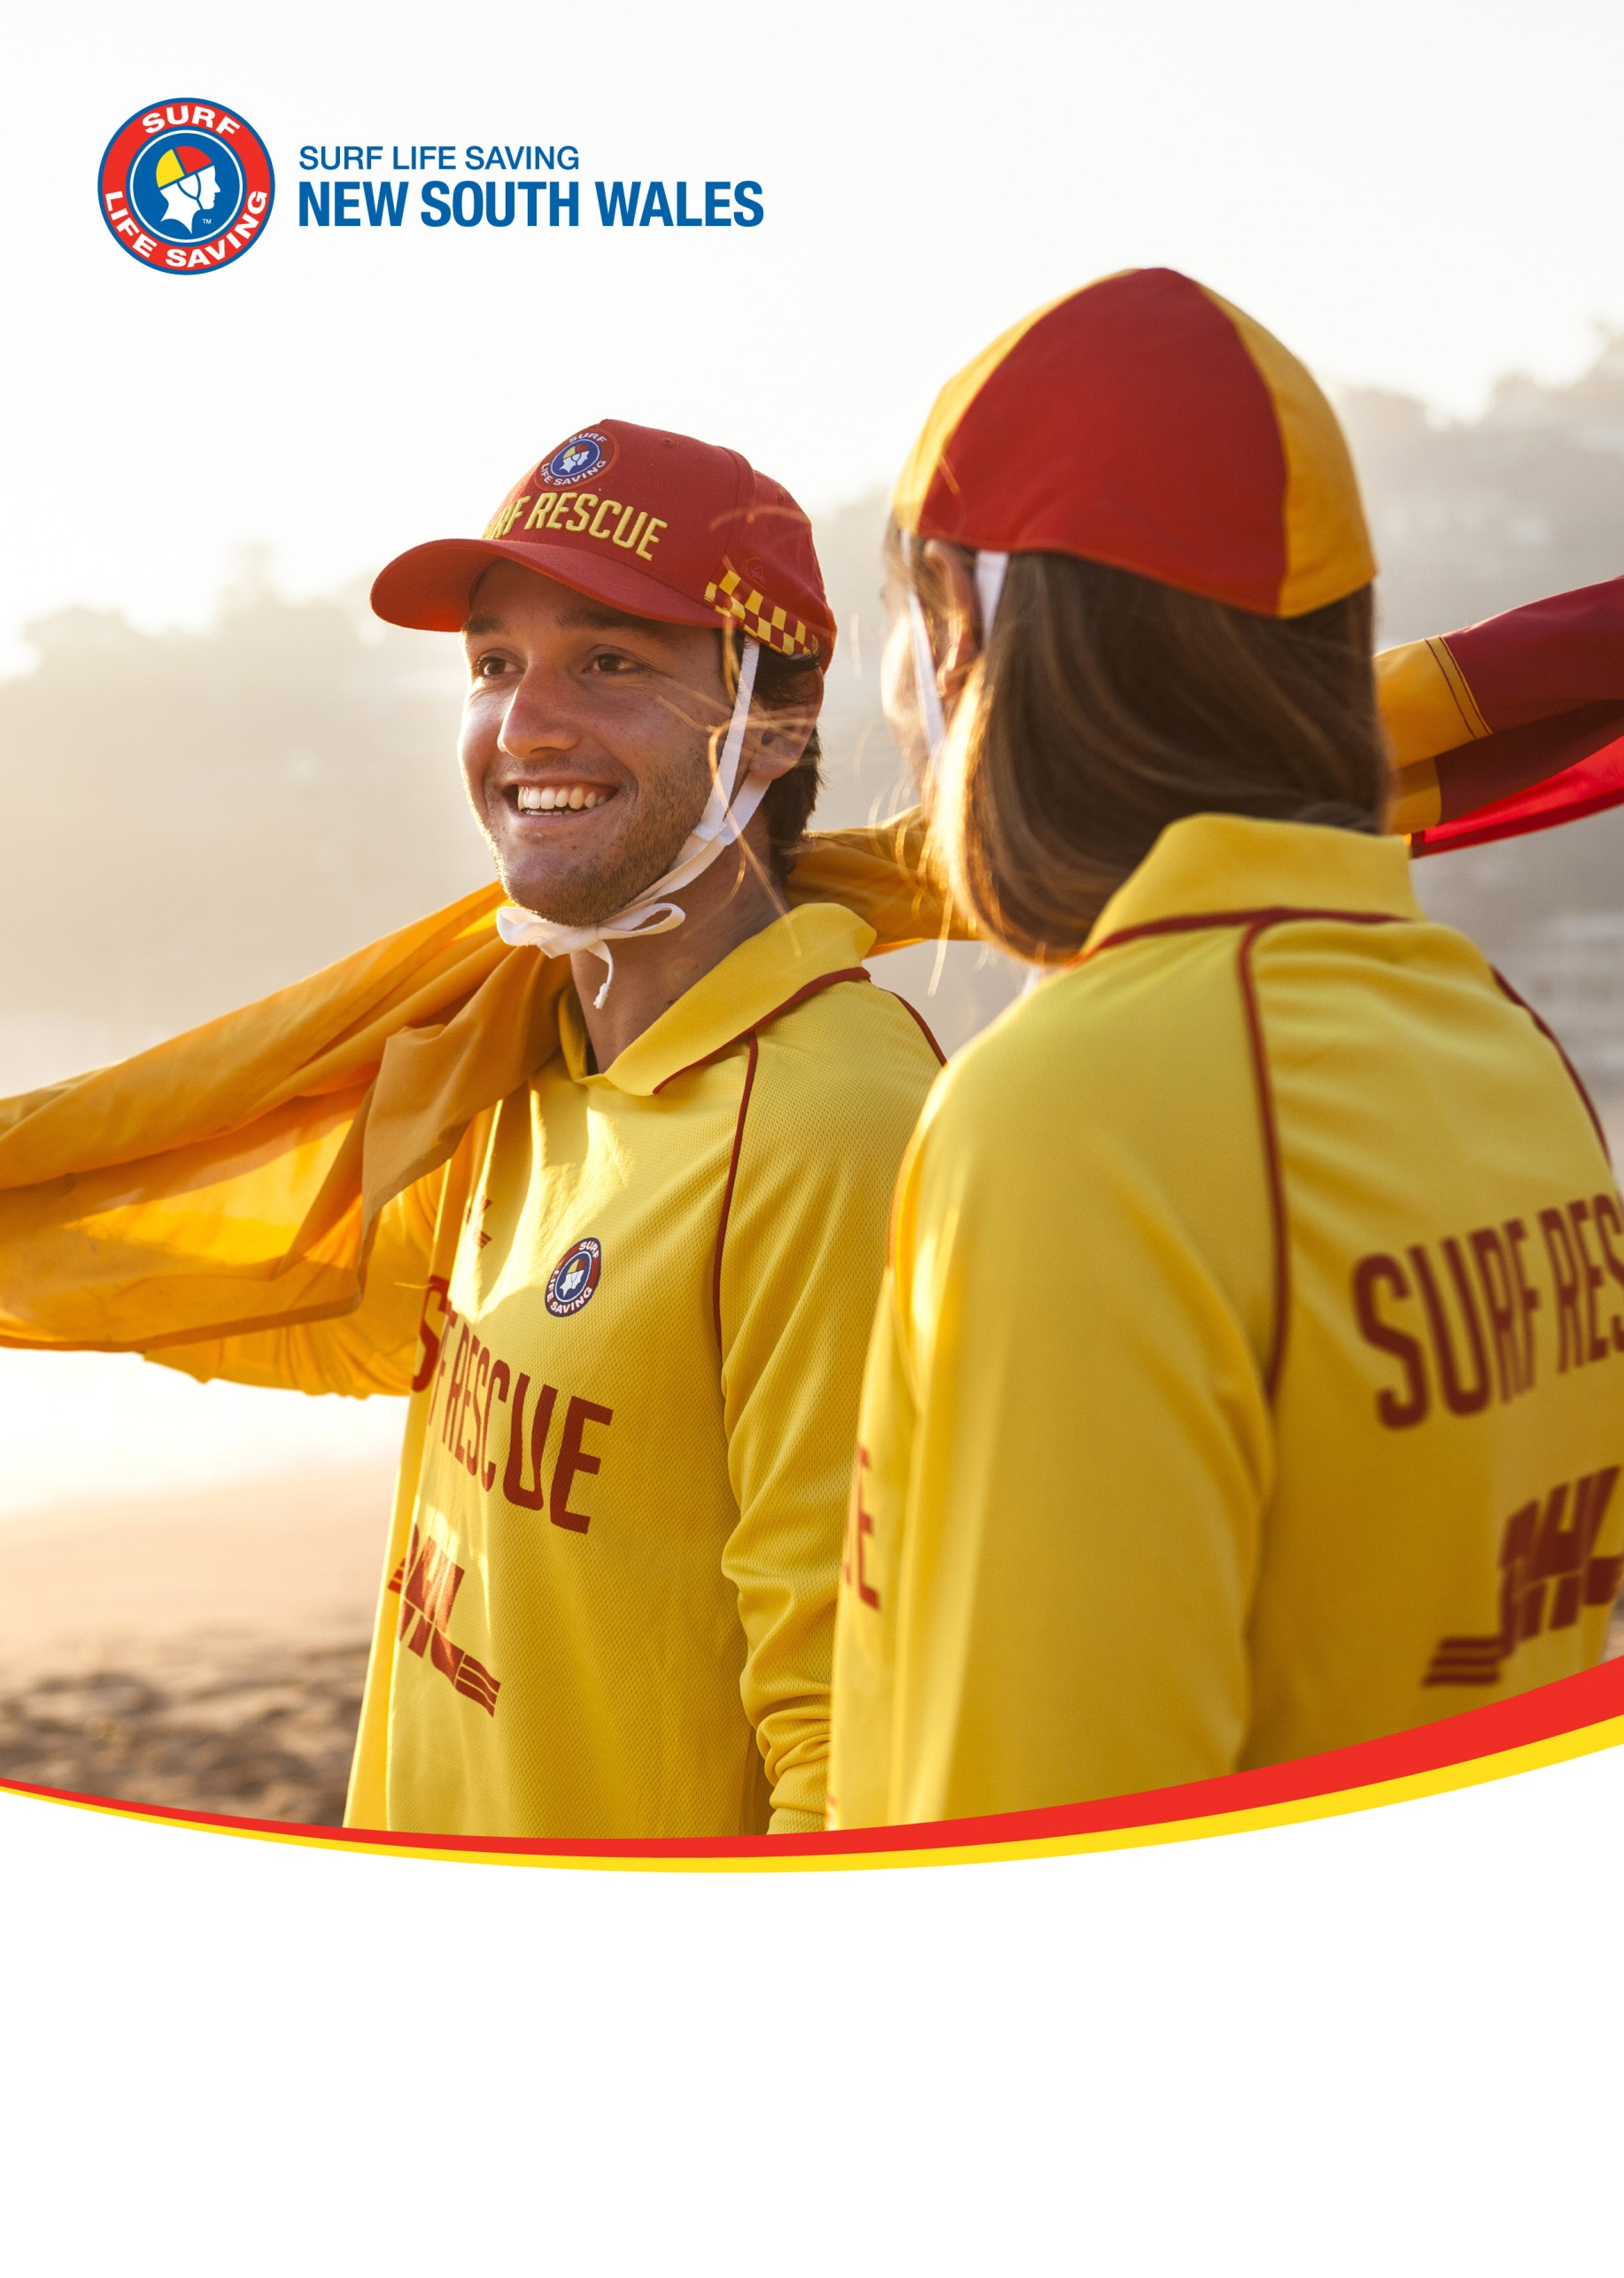
Umina Beach SLSC
Patrol Operations Manual
1 Communication 3
1.1 Surf Life Saving & Emergency Services 3
1.2 Club Callout Team 4
1.3 Club Radio Procedures 5
2 Hazard/Risk Management 6
2.1 Hazard/Risk Map 6
2.2 Hazard/Risk Management Plan 7
2.3 Northern Emergency Response Area 7
2.4 Southern Emergency Response Area 7
3 Beach Management 8
3.1 Minimum Patrol Requirements 8
3.1.1 Personnel 8
3.1.2 Equipment 8
3.2 Patrol Types 9
3.2.1 Base Patrol 9
3.2.2 Satellite Patrol 10
3.2.3 Outpost Patrol 10
3.2.4 Beach Closed Patrol 10
3.3 Daily Patrol Procedures 11
3.3.1 Start of patrol 11
3.3.2 End of patrol 11
3.3.3 Equipment Location 11
3.4 Nippers/Water Safety 12
3.5 Club Rules 12
3.6 Local Government By-Laws 12
4 Emergency Operations Plans 13
4.1 Emergency Beach Closure 13
4.2 Emergency Beach Closure Procedure 13
4.3 Closure Periods 13
4.4 Tsunami Plan 14
4.4.1 Notification 14
4.4.2 Key Equipment 15
4.4.3 Marine Threat Response 15
4.4.4 Land Threat Response 15
4.5 Coastal Flooding Plan 16
4.5.1 Coastal Flooding Response 16
4.6 Emergency Rally Point 17
4.7 Helicopter Landing Zone 18
5 Standard Operating Procedures 19

Communication

Surf Life Saving & Emergency Services
SurfCom
Service |  | Phone |  |  | Email
State Operations Centre  Branches covered;  - Far North Coast  - North Coast  - Mid North Coast  - Lower North Coast  - Hunter  - Central Coast  - Sydney  - Illawarra |  | 02 9471 8092 |  |  | soc@surflifesaving.com.au
SurfCom (Fisherman’s Beach)  Branches covered;  - Sydney Northern Beaches  - South Coast  - Far South Coast |  | 02 9982 5666 |  |  | surfcom@surflifesaving.net.au
Emergency services such as Police, Ambulance, Fire, Helicopters, Roads and Maritime Services, Marine Rescue, National Parks and Wildlife Services and the NSW Department of Fisheries should be requested via SurfCom
Surrounding Surf Life Saving Assets
Club/Service |  | Distance |  | Response Time (Water) |  | Response Time (Land)
Ocean Beach SLSC |  | 600m |  | Less than 5 minutes |  | Less than 5 minutes
Central Coast Support Ski 5 |  | 6km |  | 10 minutes |  | N/A
Umina RWC (Emergency Only) |  | On site
Other Stakeholders
Assure Programs (Counselling) | 1800 808 374 |  | NSW Poisons Info |  |  |  | 131 126

Club Callout Team
Each Club should have an ‘Emergency Callout Team’ that can respond to incidents within the ‘Emergency Response Area’ as outlined in the Lifesaving Service Agreement. Members of the ‘Emergency Callout Team’ are to be appointed by the Club Captain and a list of active members maintained via SurfGuard.
To maximise emergency response effectiveness and personnel safety, clubs should maintain the following equipment/logistical preparedness;
- 2 x rescue tubes (with fins)
- 2 x rescue boards
- IRB (with trailer and full fuel bladder in an accessible location)
- ATV (if applicable)
- 1 x defibrillator
- 1 x oxy resuscitation kit
- 1 x first aid kit
- 1 x spinal board (with spinal collars)
- 2 x handheld radios in waterproof bags
- Personal telephone numbers contactable 24 hours with contacts (updated in SurfGuard)

Club Radio Procedures
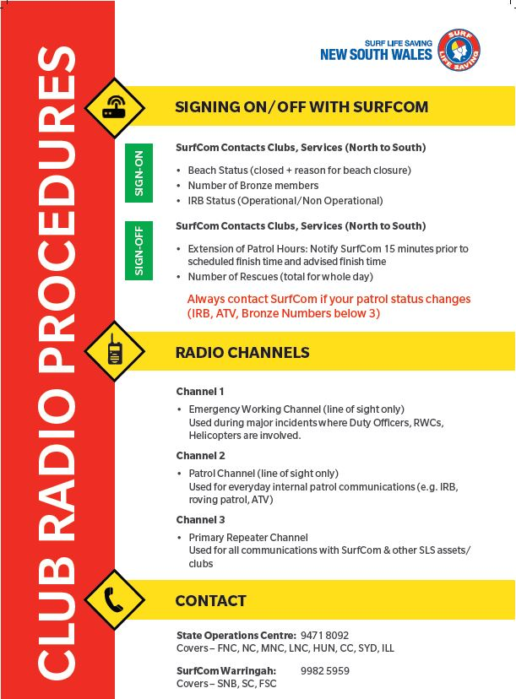

Hazard/Risk Management

Hazard/Risk Map
 | A | B | C | D | E | F | G | H | I | J | K | L | M | N
17 |  |  |  |  |  |  |  |  |  |  |  |  |  |  | 17
16 |  |  |  |  |  |  |  |  |  |  |  |  |  |  | 16
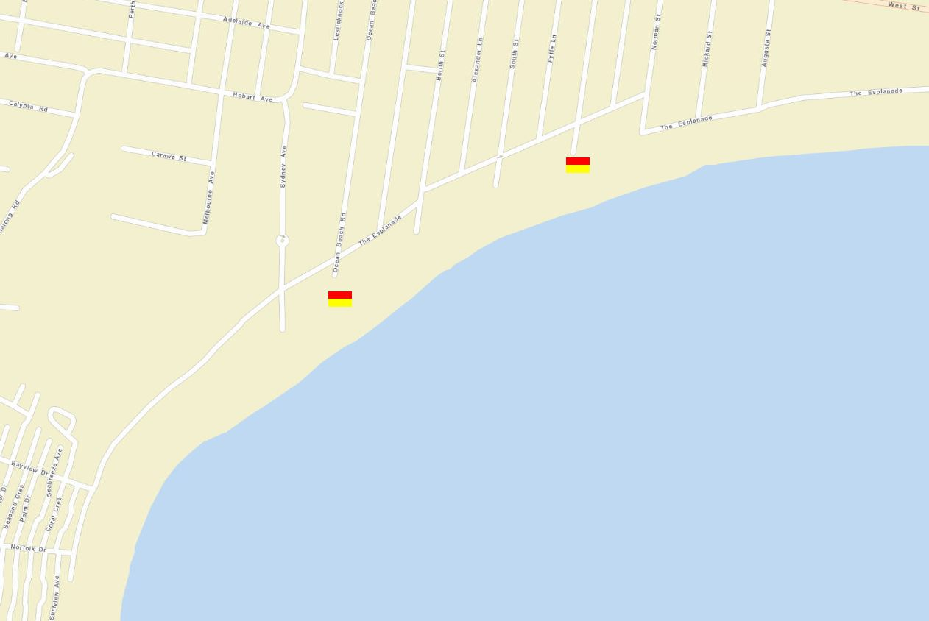  15 |  |  |  |  |  |  |  |  |  |  |  |  |  |  | 15
14 |  |  |  |  |  |  |  |  |  |  |  |  |  |  | 14
13 |  |  |  |  |  |  |  |  |  |  |  |  |  |  | 13
12 |  |  |  |  |  |  |  |  |  |  |  |  |  |  | 12
11 |  |  |  |  |  |  |  |  |  |  |  |  |  |  | 11
10 |  |  |  |  |  |  |  |  |  |  |  |  |  |  | 10
9 |  |  |  |  |  |  |  |  |  |  |  |  |  |  | 9
8 |  |  |  |  |  |  |  |  |  |  |  |  |  |  | 8
7 | Primary patrol area  From: Berith Street (H10)  To: Sydney Avenue (F12)  Secondary patrol area  From: Ocean Beach Holiday Park (E13)  To: Mount Ettalong Road (A15) |  |  |  |  |  |  |  |  |  |  |  |  |  | 7
6 |  |  |  |  |  |  |  |  |  |  |  |  |  |  | 6
5 |  |  |  |  |  |  |  |  |  |  |  |  |  |  | 5
4 |  |  |  |  |  |  |  |  |  |  |  |  |  |  | 4
3 |  |  |  |  |  |  |  |  |  |  |  | 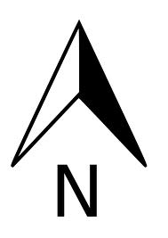 |  |  | 3
2 |  |  |  |  |  |  |  |  |  |  |  |  |  |  | 2
1 |  |  |  |  |  |  |  |  |  |  |  |  |  |  | 1
 | A | B | C | D | E | F | G | H | I | J | K | L | M | N

Hazard/Risk Management Plan
Hazard/Risk | Location (Grid Ref) | Management Plan
Rocks | A15 (heading off map) | Roving patrols in ATV and IRB  Equipment: Tube, Board, Radio  Response: IRBB, Tube, Board, from beach/water/rocks
Rips |  | Various rips and inshore drag along the beach. Monitor from tower/waters edge, roving patrols, outpost patrols if dangerous  Equipment: IRB, Tube, Board, Radio  Response: ATV/IRB, beach and water
Caravan Park/pool | C15 | Roving patrols (IRB and ATV), monitor from tower/patrol  Equipment: ATV, IRB, Board, Tube  Response: ATV, IRB
Skate park | G14 | Callouts to injuries as required  Equipment: ATV, Spinal, First Aid, Radio  Response: ATV
Pearl Beach |  | Two roving patrols per day with IRB  Equipment: IRB, Tube, Radio  Response: IRB, Tube from rocks
Helicopter Landing Zone | H14 | Equipment:  Response:

Northern Emergency Response Area
Area | Berith Street/South Street
Equipment | ATV/IRB
Response
Response Time (water - IRB) | 1 minute
Response Time (land - ATV) | 1 minute
Access (boat ramps etc) | Launch from front for Surf Club

Southern Emergency Response Area
Area | Kiddies Corner (Primary – A15), Pearl Beach, Broken Bay
Equipment | IRB, ATV, RWC
Response
Response Time (water - IRB) | 5 minutes
Response Time (land - ATV) | 2 minutes to Kiddies Corners, N/A to Peal Beach
Access (boat ramps etc) | Launch from front of Surf Club  Vehicle access southern end of Umina Beach, southern end of Pearl Beach

Beach Management

Minimum Patrol Requirements

Personnel
A patrol is to consist of a minimum of three (3) personnel, with the below qualifications held amongst the three (3) members;
- 3 x bronze medallion
- 1 x Advanced Resuscitation Techniques Certificate (ARTC)
- 1 x IRB driver
- 1 x IRB crew
- 1 x Basic Beach Management (held by Patrol Captain)

Equipment
A patrol is to set up their beach with items of equipment, as a minimum;
- IRB (with trailer)
- Rescue craft access signs (where an IRB/RWC is launched from)
- 3 x handheld radios in waterproof bags
- 2 x ‘swimming not advised’ (or ‘beach closed) mobile signs
- Patrol information board
- ATV/vehicle (where applicable)
- Tower or shade (tent)
- 2 x rescue boards
- 3 x rescue tubes
- 1 x defibrillator
- 1 x oxy resuscitation kit
- 1 x first aid kit
- 1 x spinal board (with spinal collars)
- 1 x binoculars
- Set of red and yellow feathered patrol flags
- Set of black and white chequered surfcraft boundary flags

Patrol Types
For detailed descriptions of the various patrol types that can be conducted, please refer to the Standard Operating Procedures, LS4.3 Club Patrol Types.
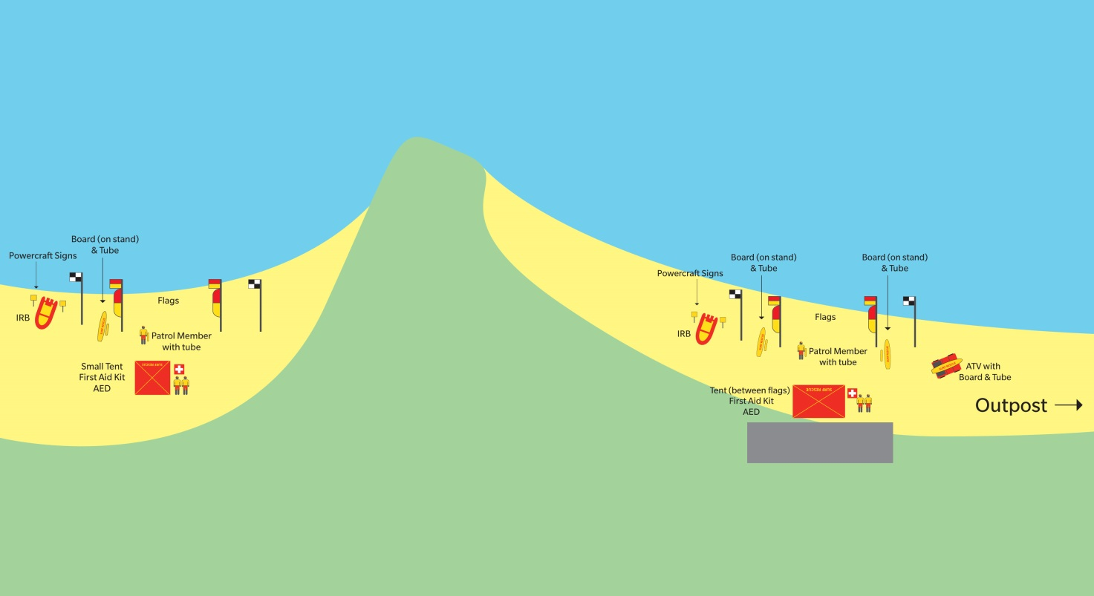

Base Patrol
A Base Patrol is the core patrolled area for a lifesaving service established at all times and dates as identified in the Lifesaving Service Agreement. A Base Patrol must meet all minimums for personnel and equipment as stated below to be considered ‘beach open’.
A Base Patrol may be supported by multiple Sub Patrols to effectively manage the beach operations as identified in the services Patrol Operations Manual.
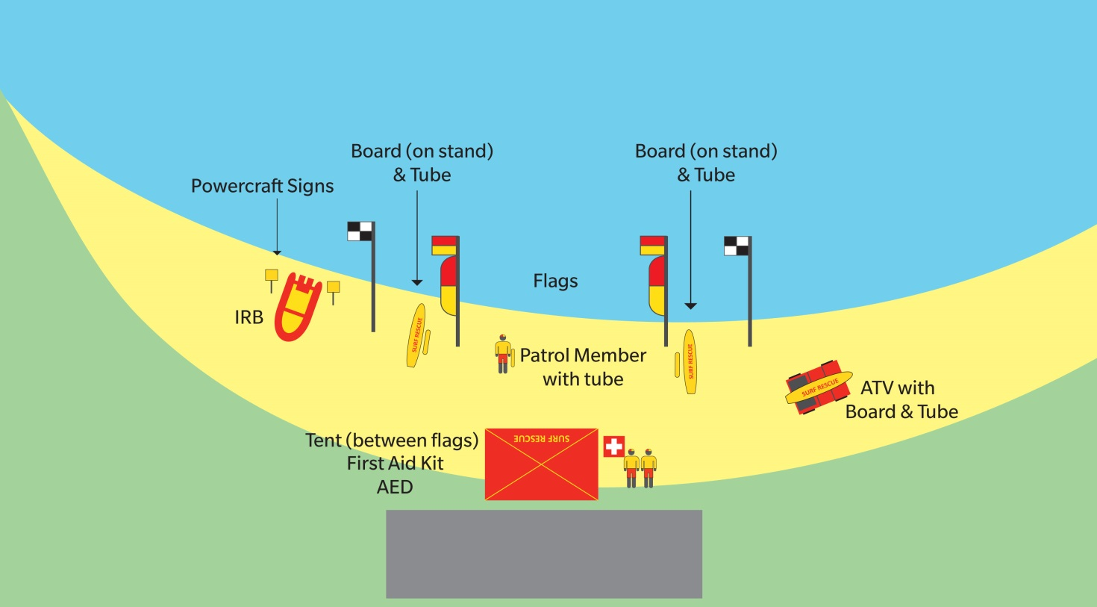

Satellite Patrol
A Satellite Patrol is a sub patrol type with patrol flags, and operates as an extension of the Base Patrol, as defined within the services’ Patrol Operations Manual to provide surveillance at an area of high risk. A Satellite Patrol may operate almost independently of a Base Patrol due to similar minimum requirements.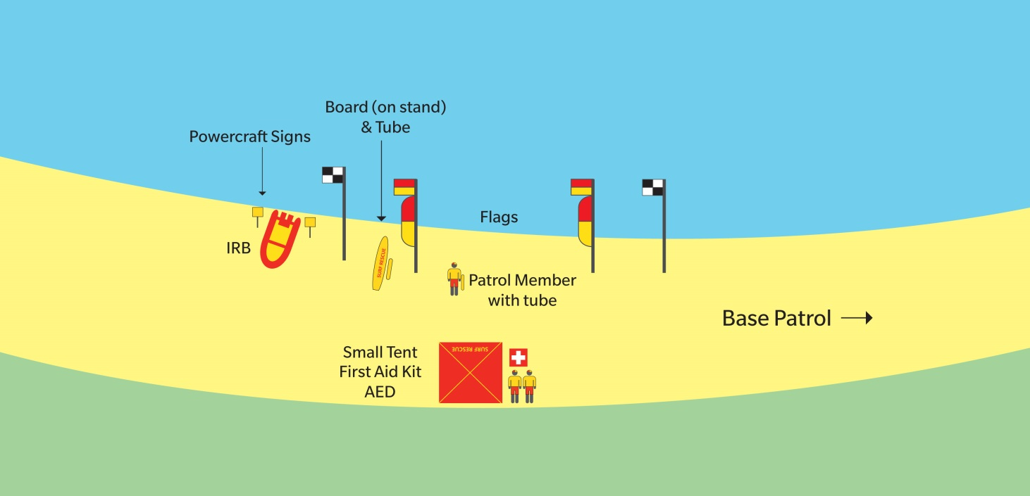

Outpost Patrol
An Outpost Patrol is established at other areas of coastline. This sub patrol type has no patrol flags, and operates as an extension of the Base Patrol, as defined within the services’ Patrol Operations Manual to
provide surveillance at an area of high risk.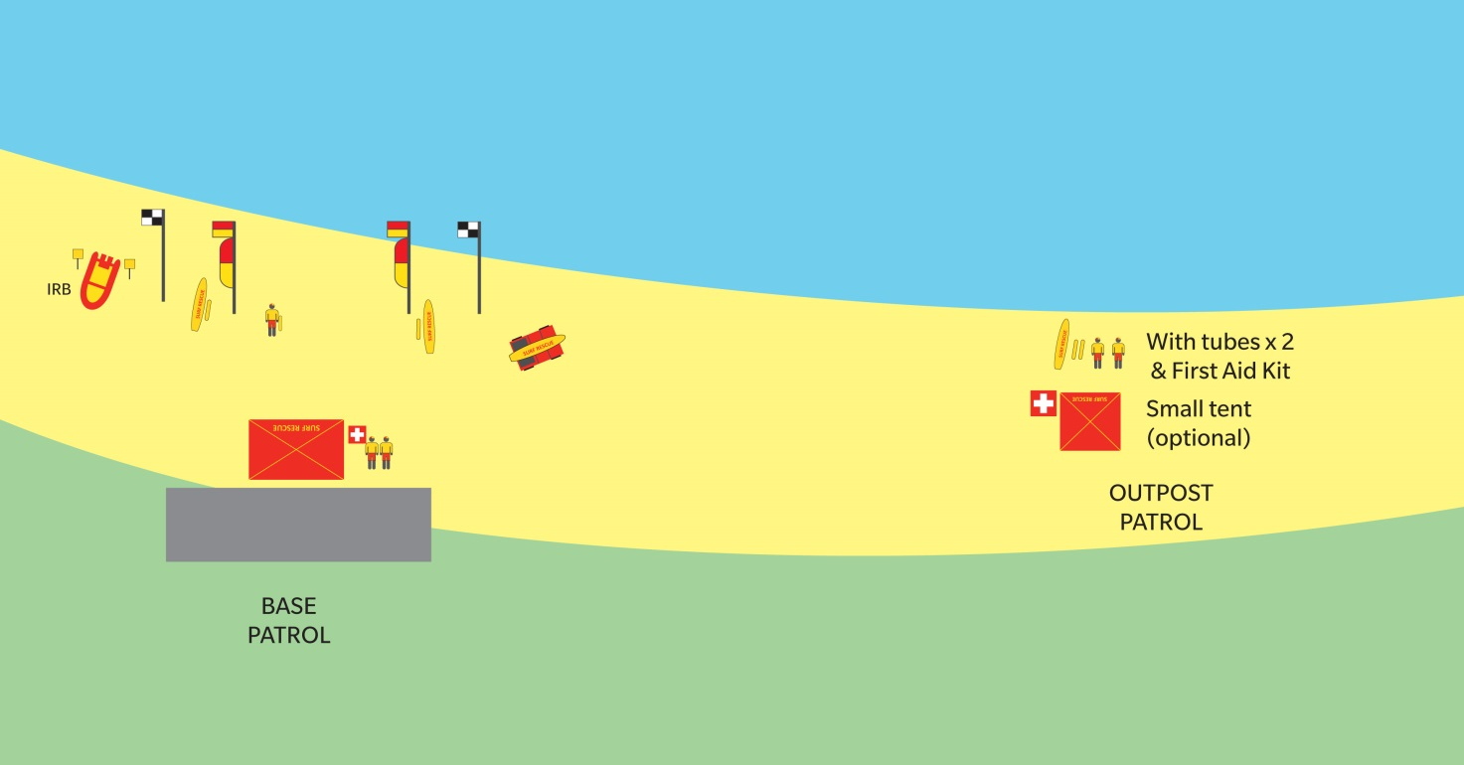

Beach Closed Patrol
A Beach Closed Patrol is Base Patrol with a closed swimming area. The swimming area may be closed for situations such as dangerous conditions or an emergency.
A Beach Closed Patrol includes all minimum personnel and all minimum equipment with the exception of patrol flags.

Daily Patrol Procedures
Add/remove items to the below lists as required.

Start of patrol
- All members arrive at least 15min prior to start of patrol
- Minimum standards assessed (numbers, qualifications, gear)
- Equipment should be checked and positioned for patrol
- Flagged area established
- Patrol log completed
- Patrol signed on with SurfCom
- ‘Patrol Briefing’ conducted by Patrol Captain, discussing;
  - Uniform standards
  - Member roles/responsibilities
  - Rotation schedule/positioning
  - Radio use (channels/call-signs)
  - Expected weather/surf conditions
  - Expected hazards and management
  - Induction/introduction of any new members

End of patrol
- Scanning/surveillance of beach maintain by at least one lifesaver during ‘pack-up’
- Rescue equipment (radio, tube, board, IRB) to remain at ‘rescue ready’ status during ‘pack up’
- Patrol log, Incident log and Powercraft log completed
- Patrol signed off with SurfCom
- All equipment cleaned and stored appropriately
- Radio’s placed on charge
- Any supply requirements or equipment damage reported to relevant club officer
- ‘Patrol Debrief’ conducted by Patrol Captain, discussing;
  - Rescues/incidents and key activities from the day
  - Any questions/concerns from patrol members
  - Upcoming events/opportunities
  - Training options
  - Next patrol date

Equipment Location
Add/remove items to the below lists as required.
Item | Location
IRB | Gear shed
Radios | Patrol room
Patrol shade (tent) | Gear shed (on patrol trailer)
Rescue boards | Gear shed
Rescue tubes | Gear shed
Defibrillator | First aid room/ATV/Patrol Trailer
Oxy resuscitation kit | First aid room/ATV/Patrol Trailer
First aid kit | First aid room/ATV/Patrol Trailer
Spinal board | ATV/Patrol Trailer/First aid room
Binoculars | Patrol Tower/Patrol Trailer
Patrol flags/signage | Gear Shed, Patrol Trailer

Nippers/Water Safety
Nipper activities (and like activities) are to adhere to the SLSA Water Safety Policy (SLSA Policy 1.01) at all times. Nipper activities are to only be conducted in the immediate vicinity of an active patrolled area and have its own sufficient water safety (minimum 1 water safety for every 5 participants). It is highly recommended that an IRB be available water safety. The IRB should be on the water, rather than stationary on the beach.
Nipper activities cannot be undertaken on a closed beach.
The Patrol Captain is to have ‘control’ over all Nipper activities and may delegate to a Nipper Coordinator.

Club Rules
- Full patrol uniform must always be worn on patrol
- At least one (1) patrol member to always be watching the water
- At least one (1) patrol member always monitoring the radio (channel 2 and channel 3)
- The Patrol Captain is to always be made aware of all member locations/activities
- At least one (1) patrol member at the water’s edge with a tube and radio when swimmers are in the water
- Rescue tubes are to always be carried by patrol members when on the beach
- Rescue tubes should not be tied to flag poles
- Members should not text, sun bathe or engage in any unprofessional behaviour (in uniform) in public view
- Only qualified IRB driver and crew are to operate the IRB
- Only licensed drivers to operate the ATV
- The ATV should always be left facing the water (out of gear and in neutral)
- ATV should always be driven at a low speed (unless in an emergency)
- No passengers are allowed in the tray of the ATV (unless in an emergency)
- The Club Captain or relevant officer should be notified immediately of any equipment damage/issues
- Patrol will adhere to full start and end of patrol procedures
- All paperwork is to be completed for each patrol (including patrol log, incident log and Powercraft log)

Local Government By-Laws
Local By Law | Management Plan
Joint Share Equipment | ATV, Defibrillator and some general areas of the club are joint shared with Gosford City Council Lifeguards
Dog off leash area | Dogs are allowed off leashes after the 3rd walkway south-west from the main walkway in front of the club

Emergency Operations Plans

Emergency Beach Closure
Patrol Captains should consider the ‘closure’ of a beach at any time that there is an unacceptable/unmanageable risk to the public of the lifesaving service is unable to safely perform water safety tasks. For a detailed procedure, refer to Standard Operating Procedure ‘LS 9.1 Emergency Beach Closure.’
Examples include;
- Dangerous surf conditions
- Sharks
- Excessive stingers
- Powercraft hazards
- Lightning
- Tsunami/flood warning
- Storm pollution
- Chemical/fuel spill

Emergency Beach Closure Procedure
- Determine if water area is to be evacuated
- Inform SurfCom that you are about to close the patrolled area
- Activate the ‘Emergency Evacuation Alarm’
- Inform every one of the following;
  - Water area is being closed; and
  - Reason for closure
- Lower and remove the red and yellow patrol flags and black and white surfcraft flags
- Post ‘Swimming not advised’ signs at identified beach access points and where the flagged area was located
- Continually monitor all areas
- Maintain minimum personnel, qualification and equipment requirements
- Maintain an active presence on the beach to advise/warn public
- An appropriate record should be made in the patrol log giving an outline of the incident

Closure Periods
Generally the beach will remain closed until such time as the identified hazard is controlled or no longer presents a risk.
Recommended closure periods include;
- Dangerous surf conditions – as determined/appropriate
- Shark – minimum 30 minutes from last confirmed sighting (or completion of search)
- Chemical/biological hazards – after confirmation from appropriate authorities that the area is safe

Tsunami Plan
Surf Life Saving New South Wales is recognised under the State EMPLAN as a ‘support agency’ in a Tsunami event. Broadly, our role includes;
- Contribute to tsunami community education initiatives
- Assist the SES with the dissemination of warnings
- Close and evacuate beaches on receipt of a NSW Tsunami Warning or upon observation of unusual ocean behaviour indicative of a tsunami, in consultation with Local Government Councils
- Assist with the rescue of people from the surf zone following the impact of a tsunami
- Notify the SES when unusual ocean behaviour indicative of a tsunami is observed or a tsunami has occurred for which there has been no prior warning
For a detailed procedure, refer to Standard Operating Procedure ‘LS 9.12 Tsunami Warning’ and the ‘Surf Life Saving New South Wales Tsunami Plan.’
Each Surf Life Saving Club has an obligation to be prepared and respond as outlined in the ‘Surf Life Saving New South Wales Tsunami Plan’.
There are two types of tsunami threats;
- Marine threat – may influence currents/rips/water energy and immediate foreshore (more common)
- Land threat – may impact coastal areas, inlets and inland inundation (rare event, but significant impact)

Notification
The SES is the ‘lead agency’ for tsunami response and will advise Surf Life Saving of a tsunami warning through the State Duty Officer, who will co-ordinate the Surf Life Saving response.
Due to the location of ‘fault lines’ (starting points of tsunami’s) a warning should precede the tsunami impact by a number of hours.
Depending on the time of day/year, the notification process will differ, however will remain similar to the standard emergency response notification;
Patrols on duty
- State Duty Officer notifies SurfCom and Branch Duty Officer
- SurfCom advises on duty patrols of tsunami warning and to activate their ‘Club Tsunami Response Plan’
Patrols not on duty
- State Duty Officer notifies Branch Duty Officer
- Branch Duty Officer notifies ‘Club Emergency Response Teams’ who activate their ‘Club Tsunami Response Plan’

Key Equipment
The following equipment (minimum) is key to maintaining a viable lifesaving service during a tsunami warning (both marine and land threat) and restoring the service following the impact of a tsunami to a ‘rescue ready’ status. This equipment should be moved to a safe location prior to the tsunami’s impact (marine and land threat);
- IRB (with trailer)
- 3 x handheld radios in waterproof bags
- 2 x ‘swimming not advised’ (or ‘beach closed) mobile signs
- 2 x rescue boards
- 3 x rescue tubes
- 1 x defibrillator
- 1 x oxy resuscitation kit
- 1 x first aid kit
- 1 x spinal board (with spinal collars)
- 1 x binoculars

Marine Threat Response
- Club advised of tsunami warning
- Patrol/flagged area closed
- Evacuation alarm sounded (continuous siren)
- Evacuation flag erected (red and white quartered)
- Swimmers/surfers etc evacuated from water
- Members of the public evacuated from foreshore
- ‘No swimming’ signage erected
- Relocate key patrol/response equipment away from the foreshore
- Prepare to evacuate all personnel and key equipment if warning is upgraded to a ‘land threat’
- Maintain preparedness to respond to emergencies until threat has passed (official notification from SurfCom/Branch Duty Officer)
- Upon clearance from SurfCom/Branch Duty Officer return to normal operations (stand down)

Land Threat Response
- Club advised of tsunami warning
- Patrol/flagged area closed
- Evacuation alarm sounded (continuous siren)
- Evacuation flag erected (red and white quartered)
- Swimmers/surfers etc evacuated from water
- Members of the public evacuated from foreshore, car park and immediate area
- ‘No swimming’ signage erected
- All non-essential personnel sent home
- Transport ‘key equipment’ and remaining personnel to pre-determined rally point (see 5.6 Emergency Rally Point)
- Inform SurfCom/Branch Duty Officer when evacuation to rally point is complete
- Maintain preparedness to respond to emergencies until threat has passed (official notification from SurfCom/Branch Duty Officer)
- Respond to incidents following tsunami impact as directed by SurfCom/Branch Duty Officer
- Upon clearance from SurfCom/Branch Duty Officer return to normal operations (stand down)

Coastal Flooding Plan
Surf Life Saving New South Wales is recognised under the State EMPLAN as a ‘support agency’ in a coastal flooding event. Broadly, our role includes;
- Assist the SES with the warning and/or evacuation of at risk communities
- Provide space in Surf Life Saving facilities for evacuation centres where required
- Assist the SES with flood rescue operations
For a detailed procedure, refer to Standard Operating Procedure ‘LS 9.11 Coastal Flooding.’
Each Surf Life Saving Club has an obligation to be prepared and respond in line with a ‘land threat’ tsunami warning.
Coastal areas are likely to be affected by either ‘flash flooding’ or ‘storm surge’ flooding. ‘Storm surge’ flooding will generally coincide with high tides and is easier to predict and prepare for. ‘Flash flooding’ is unpredictable and occurs in a short period of time, occasionally a storm warning may be issued prior to the flooding event.

Coastal Flooding Response
- Club advised of coastal flooding warning
- Patrol/flagged area closed
- Evacuation alarm sounded (continuous siren)
- Evacuation flag erected (red and white quartered)
- Swimmers/surfers etc evacuated from water
- Members of the public evacuated from foreshore, car park and immediate area
- ‘No swimming’ signage erected
- Prepare Clubhouse as an ‘emergency evacuation centre’
- All non-essential personnel sent home
- Transport ‘key equipment’ and remaining personnel to pre-determined rally point (see 5.6 Emergency Rally Point)
- Inform SurfCom/Branch Duty Officer when evacuation to rally point is complete
- Maintain preparedness to respond to emergencies until threat has passed (official notification from SurfCom/Branch Duty Officer)
- Respond to incidents as directed by SurfCom/Branch Duty Officer
- Upon clearance from SurfCom/Branch Duty Officer return to normal operations (stand down)

Emergency Rally Point
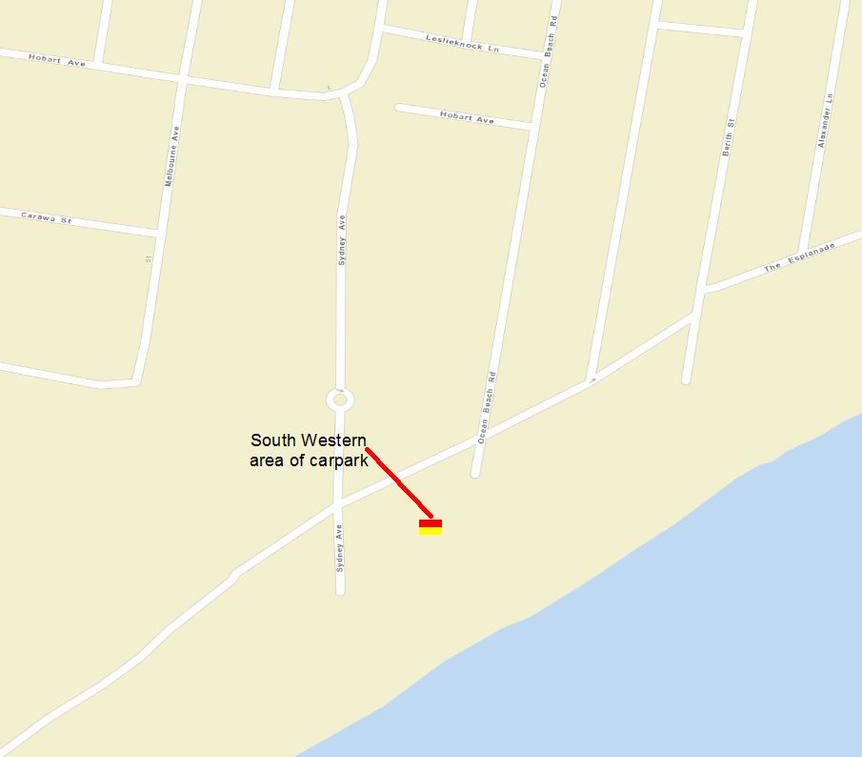
Emergency rally point location: Carpark next to toilet block, Sydney Avenue

Helicopter Landing Zone
During major incidents, rescue helicopters may be required to land on the beach or near the beach to assist treating the patient and possibly transporting the patient to hospital. Ultimately, the decision of where to land is made by the pilot of the aircraft based on weather conditions, the nature of the incident and surrounding hazards. Patrol Captains can prepare and suggest a landing zone using local knowledge prior to a helicopter arriving.
Things to consider when establishing a helicopter landing zone;
- 40m x 40m area (minimum)
- Flat and cleared of hazards (loose objects, power lines, trees, etc)
- Helicopter will approach the landing zone against the wind
- At night the landing zone should be expanded to at least 30m x 30m
Helicopter Landing Zone procedure;
- Nominate a suitable lifesaver as ‘landing zone controller’ and provide a radio
- ‘Landing zone controller’ briefs lifesavers on pre-landing and post-landing procedures
- Landing zone cleared of all loose objects, vehicles and people
- Landing zone established with minimum 40m x 40m area and marked with cones.
  - Lifesavers to ensure landing zone is maintained and members of the public do not enter the area
  - ‘Landing zone controller’ is to be positioned on the side of the landing zone that the helicopter will land towards
- Establish contact with helicopter of ‘Surf Channel 1’ prior to landing and confirm suitability of landing zone. Provide a summary of key hazards (trees, power lines) within the area
- Helicopter lands, lifesavers ensure perimeter is maintained until helicopter departs
- Do not approach the helicopter and await instructions from the helicopter crew (only approach the helicopter from the front and once given the all clear from the helicopter crew)
- Ensure loose objects are secured and landing zone is clear of people prior to helicopter taking off
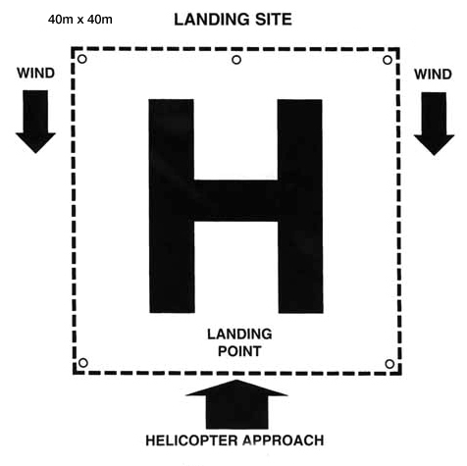

Standard Operating Procedures
For detailed information on Lifesaving procedures and policies, refer to the Standard Operating Procedures on the Surf Life Saving New South Wales website.
- LS2 Work health and safety
- LS3 Information management
- LS4 Obligations and Standards
- LS5 Regulations – rescue vessels
- LS6 Gear and equipment
- LS7 Radio communications
- LS8 Patrol operations (general)
- LS9 Patrol operations (emergency)
- LS10 Emergency response system
- LS11 SAR operations
- LS12 SurfComs
- LS13 Lifesaving vessels and aircraft
- LS14 Post incident (recovery phase)

