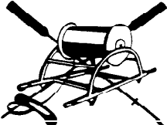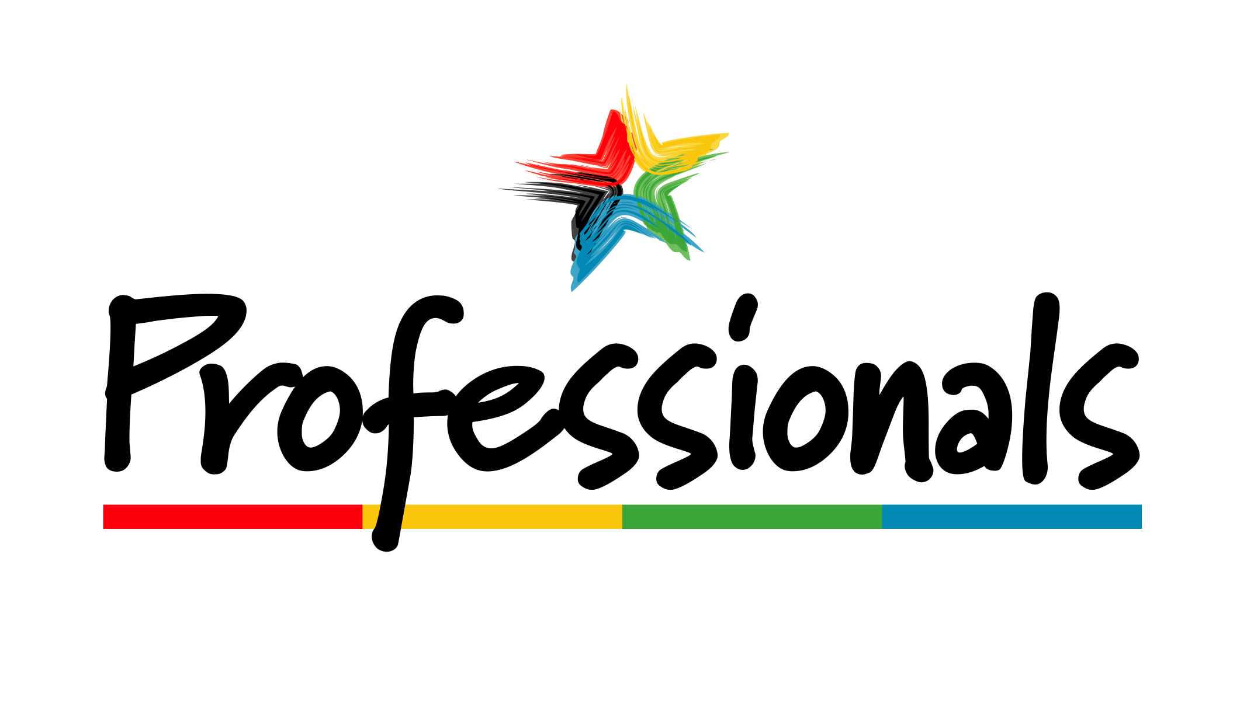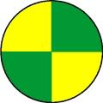
The Professionals Weekend of Surf 2015
October 3 and 4 – 20th Year
Forster Main Beach

Friday – Club open for visitors from 5pm –

Saturday - Ironman 10.00am start
Saturday – 3 Person Board Relay
AFL Grand Final and BBQ
Sunday – Surf Carnival from 8.30am
Water Safety 1-5 and officials 1 -7

7.15pm Watch the NRL Grand Final - food and drinks available

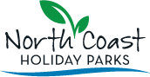 webberarchitects 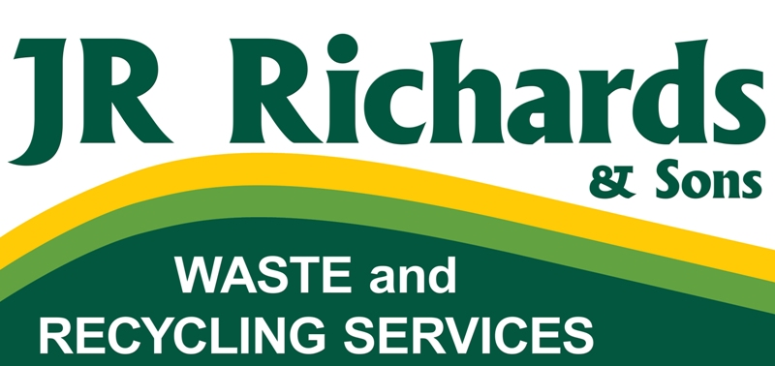 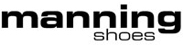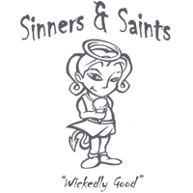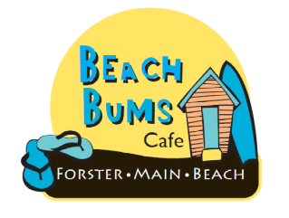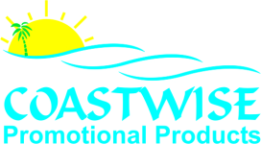 Taree Engraving Services 

